***PRESS RELEASE***

**CARITAS LEBANON MIGRANTS CENTER, IN COOPERATION WITH THE PILIPPINE EMBASSY, HOLDS A HOLY MASS FOR THE VICTIMS OF TYPHOON YOLANDA**

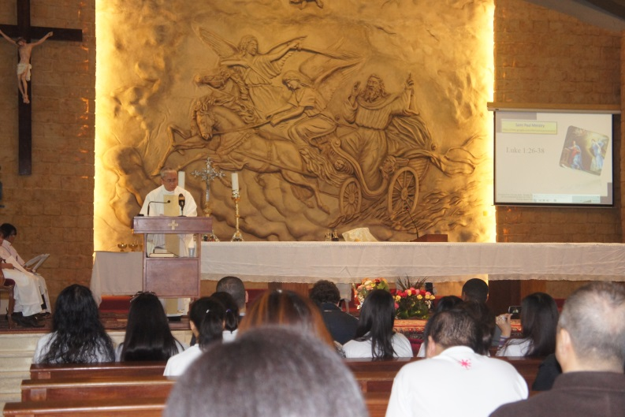  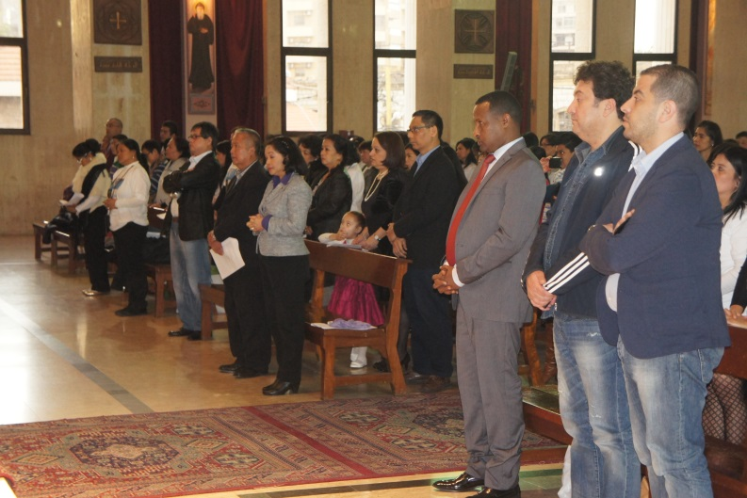

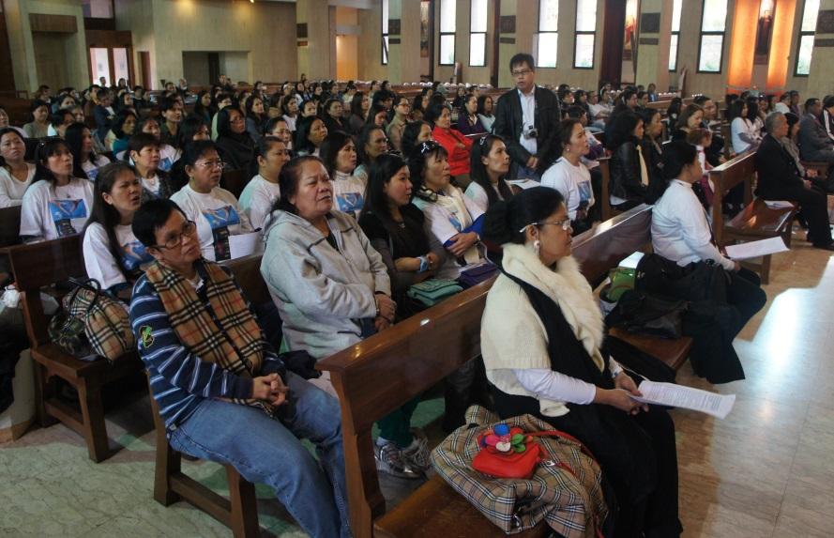 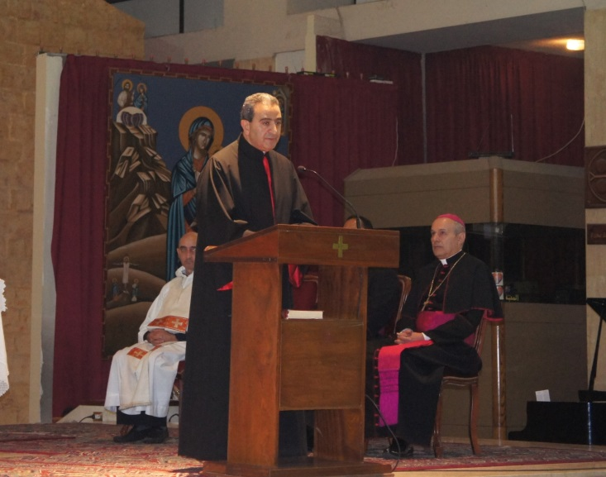

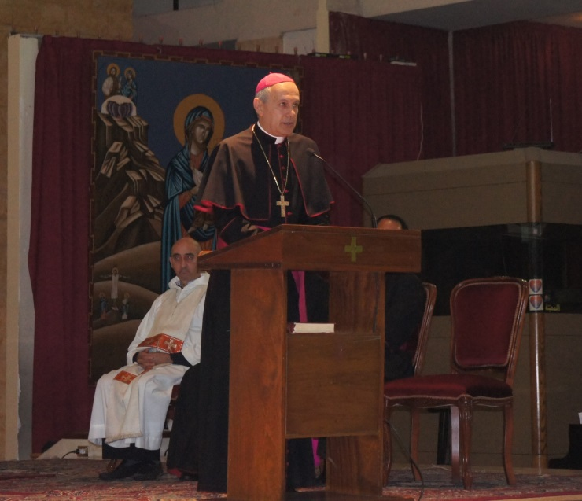 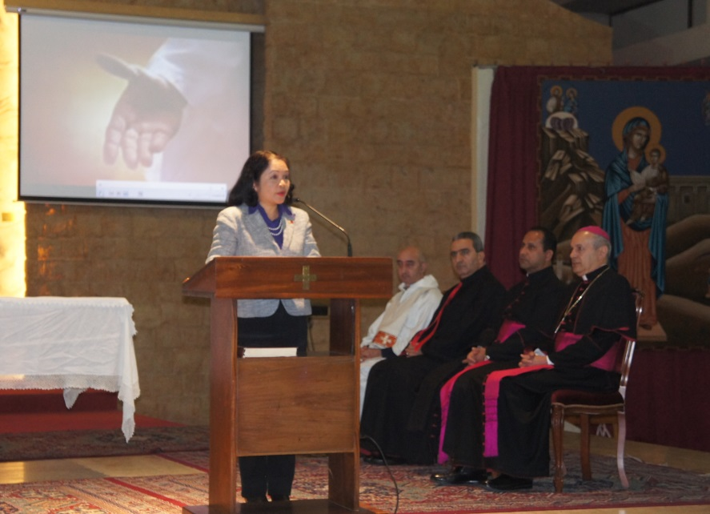

***PHOTOS:***

***FIRST ROW LEFT*** *– Mass celebrant, Fr. Agustin Advincula CM, delivers his homily;* ***FIRST ROW RIGHT –*** *participants stand for the community prayers;* ***SECOND ROW LEFT –*** *at least 200 Filipinos and Lebanese attend the mass;* ***SECOND ROW RIGHT –*** *Rev. Fr. Simon Faddoul delivers his message;* ***THIRD ROW LEFT –*** *H.E. Monsignor Gabriele Caccia delivers his message;* ***THIRD ROW RIGHT –*** *Ambassador Leah M. Basinang-Ruiz delivers a message of thanks, as Mgr Caccia, Mgr Jain Mendez, Fr. Faddoul and Fr. Louis Taoutel, SJ listen.*

**16 December 2013** – The Caritas Lebanon Migrant Center (CLMC), in cooperation with the Philippine Embassy, Lebanon held a mass on 08 December 2013 for the victims of typhoon Yolanda in central Philippines, to offer prayers for the speedy recovery of those who were affected by the typhoon and to show its solidarity with the Filipino people. Members of the diplomatic corps led by the Papal Nuncio and Dean of the Diplomatic Corps, H.E. Monsignor Gabriele Caccia, Lebanese individuals, Filipino-Lebanese families, members of the Filipino community, CLMC officers and staff led by Caritas Lebanon President Rev. Fr. Simon Fadoul, CLMC Board President Engineer Kamal Sioufi and CLMC Director Ms. Najla Chahda, and the Embassy, POLO and OWWA personnel led by Ambassador Leah M. Basinang-Ruiz were present.

Rev. Fr. Fadoul and Monsignor Caccia delivered their respective messages where they expressed their support and offered prayers for the victims of the typhoon. Monsignor Caccia likewise conveyed the Holy Father, Pope Francis’ message of sympathy to the Filipino people and prayers for the victims of the typhoon.

Ambassador Ruiz highlighted the presence of Mgr. Caccia as a concrete manifestation of the concern and love by the Holy Father for the Filipino people. She thanked the CLMC officers and staff for organizing the Holy Mass and the Lebanese community for their support and presence. Ambassador Ruiz also stated that the mass offering is a wonderful and concrete gesture of sympathy, solidarity and support from Lebanon, which will always be remembered by a grateful nation. **END**.