***PRESS RELEASE***

**PHILIPPINE EMBASSIES IN DAMASCUS AND BEIRUT IN COOPERATION WITH IOM REPATRIATE 31 FILIPINOS FROM SYRIA**

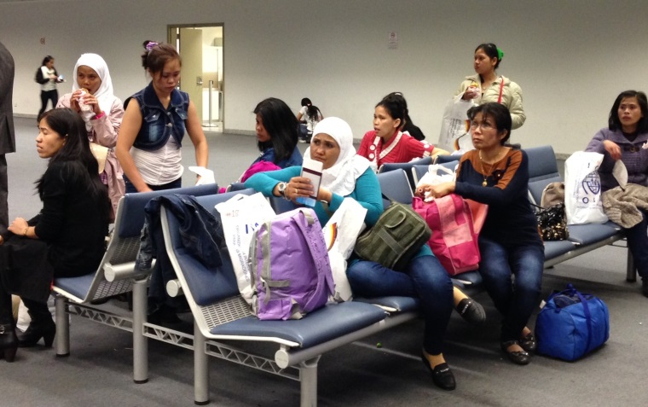 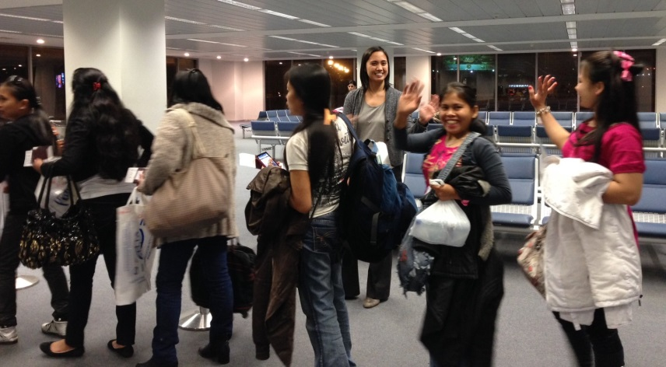

*The repatriates wait for their flight to Manila at the boarding gate at Vice Consul Goce guides the repatriates as they line up to board their Emirates the Rafik Hariri International Airport flight to Manila via Dubai*

**09 December 2013** – The Philippine Embassies in Damascus, Syria and Beirut, Lebanon with the support of the International Organization for Migration (IOM) once again facilitated the successful repatriation to the Philippines of another batch of 31 Filipinos from Syria on Tuesday, 03 December 2013. The IOM again provided the airfare, land transportation and meals of this batch of repatriates.

The same-day cross-border repatriation operation commenced in the morning of 03 December 2013, when Vice Consul Rona Beth Goce and Cultural Officer Gladys Perey proceeded to the General Security (Lebanese immigration) at Masna’a border, where they met the team from IOM. At the Masna’a, the Beirut PE and IOM teams received the 31 Filipinos from the officers of Damascus PE and then assisted the repatriates undergo immigration entry procedures.

From the Masna’a border, Vice Consul Goce and Ms. Perey escorted the repatriates directly to the Rafik Hariri International Airport for their evening flight to Manila via Dubai. At the airport, Vice Consul Goce and Embassy Property Officer and Administrative Assistant Chloe Silverio assisted the group for the check in and immigration clearance procedures.

At exactly 7:25 P.M., the repatriates left Beirut for Dubai where they would be taking their flight to Manila. The group was scheduled to arrive in Manila on 04 December 2013 at 4:00 P.M. via Emirates flight EK 332.

This was the **41st cross-border operation** undertaken by the two Embassies. The departure of this group of 31 Filipinos brought to **2,042** the total number of Filipinos repatriated from Syria via the Rafik Hariri International Airport in Beirut since the first cross-border operations on 12 December 2012. **END**